6COSC023W – Project Specifications Design and Prototype

Project Title

Student: Vasileios Protopapas (W1735144)

Supervisor: Panagiotis Chountas

This report is submitted in partial fulfillment of the requirements for the

BSc (Hons) Business Information Systems

at the University of Westminster.

School of Computer Science & Engineering

University of Westminster

Date : 21/01/2022

**PDSP Scope:** The purpose of the PSDP document is to list the  Project’s overarching aim and main objectives, provide a refined list of project requirements classified as functional / non functional, as well as basic /essential / luxury (or must have, should have, could have, won't have), discuss the method for their elicitation,  analyse and model requirements using appropriate diagrams and tools, develop a preliminary design and its matching implementation.

**All word counts in this document are approximate and are not intended to be prescriptive.**

# Table of contents

Provide a table of contents, linking the report Sections and Subsections to page numbers. If you can, hyperlink the page numbers/sections.

Table of Contents

6COSC023W – Project Specifications Design and Prototype 1

Project Title 1

Table of contents 3

List of figures 4

1. Aim and Objectives 5

2. Requirements 6

2.1 Stakeholders 6

2.2 Gathering requirements 6

2.3 List of project requirements 10

2.4 Modelling requirements and relevant diagrams 11

3. Preliminary Design and Prototype 15

5. Bibliography 15

Appendix I 16

# List of figures

Provide a list of figures, linking figure numbers to page numbers. If you can, hyperlink the page numbers/figures.

## Aim and Objectives

*300 words*

The aim(s) describe, in a few sentences, the overarching purpose(s)/intention(s) of the software/application. What is the point of developing the software/application, what you wish to achieve?

Objectives describe with some detail the individual steps you will take to fulfil

One of the main aims I am looking into achieving are to:

1. Provide a learning platform in which the user can interactively learn about how to use the internet
2. Create a user-friendly interface that will accommodate various devices such as mobile platforms
3. Provide a user experience that assists with users that might be visually impaired or in need of auditory feedback
4. Create a log-in system in which users can track their current progress through the learning platform.

The objectives that I am looking to achieve are as follows:

Aim 1 & Aim 3

1. Research and gather up information on various topic in relations to beginner internet usage during the next 11/2 weeks.
2. Identify all the different approaches that would be suitable methods to best suit the interactive approach to the website for example text to speech aided articles, quizzes, video formats/presentations. This will be operated for 2 weeks – 1 month.
3. Design and develop at least 4 different forms of interactivity for 1 month.
4. Compare current designed approach with other existing alternatives/learning platforms to contrast and improve during the last 1-2 weeks.

Aim 2

1. Research different screen sizes and platforms that are most used for web browsing for around 1 week.
2. Implementing and testing different screen sizes onto the website to ensure maximum compatibility and correct content display. (1 week)

Aim 4

1. Design and develop the log in system with intended progress tracking integration. (2 weeks)
2. Testing functionality of said log-in system (2 weeks)

The purpose for developing this software is to provide a unique learning approach to users that are just beginning to use the internet or want to get a better understanding on how different aspects of the internet works such as online banking, scam prevention and general use of their devices and other potential applications.

My goal would be to help people especially those that have a harder time traversing through the internet such as the older generations or newer users with limited learning resources to gain knowledge and experience in an engaging and meaningful manner so that they can gain independence and integrate themselves in a vastly changing digital landscape.

# 2. Requirements

## 2.1 Stakeholders

*100 words*

Describe people and, if relevant, organisations who will be administrating, using, and in general affected by your software/application. Use a relevant diagram, if necessary.

The stakeholders for my project include the end users as they are the main driving force behind this project and are one of the few external stakeholders. They will guarantee how successful the project will be in the future as a positive user experience will align with the projects aims and objectives but will also influence how the project will also potentially change

Another stakeholder will include the project manager, the development team, the marketing manager as these are the bulk of all the planning, production and how the project will reach it aims and objectives by being able to reach a wide audience through effective marketing. These will be the internal stakeholders.

## 2.2 Gathering requirements

*600 words*

Describe the techniques/procedures you used for gathering requirements. Results will be summarised in this section (use graphs, if necessary).

Notes: Detailed results/raw data from the process of gathering requirements can be included in an Appendix

The way that I am going to gather up my requirement will be through thorough researching upon secondary research topic such as already premade surveys, figures made by other organisations which specialise in the current topic at hand. For example, ageUK is one of the organisations in which I will gather up a specific portion of all my secondary research as they already specialise in my main target audience for my project, however I will also gain a better understanding if I find out from already made questionnaires a consensus on what the hurdles are for less tech literate users.

In this figure we can see that the most common devices for web browsing are mobile devices which still holds true for our main target audience of 55 and above. This means that when gathering up my requirements I will have to consider how my project will cater to different platforms and how that will decrease the barriers of entry to my target audience.

In this graph we can see that the internet retention of people aged over 65+ is considerably higher that the other age groups. Almost ¼ of that age group haven’t used the internet in over 3 months. From this I can gather that there is a lack of interest/ motivation onto using the internet especially in a largely internet dominant world and especially during the COVID-19 lockdowns during 2020-2021. This means that when gathering my requirements, I will have to create a sub system such as a progress tracker which might encourage my main target market into using the internet more frequently for actions that they might be unable to do in the digital future.

In this graph we can see that the main barriers of entry for my target market to be encouraged into internet use can be through having a platform that will assist them to take the plunge. This is especially crucial when gathering my user requirements as here I have data in which will help me understand how interactivity will play a hand into them getting taught how to use the internet as if there was someone else communicating to them through their device. This is where the text to speech will be useful as it might give a sense of additional guidance that might emulate the feel of another person and mentioned previously.

These figures show us that there are over 18m people in the UK that have difficulties being unable to properly use the internet due to specified disabilities such as hearing loss or sight loss. This is especially true for my target audience as it is more common for someone over 65+ to develop these conditions, this is further rectified by this quote from ons.gov.uk: “For adults aged 75 years and over, 41% of disabled adults and 54% of non-disabled adults were recent internet users”. This means that when I am eliciting for my requirements, I will need to consider how to make my website to accessible to these specific use cases through various methods such as, proper colour contrasting, a solution to reduce as much clicking to the webpage as possible, magnifying glasses for page zoom, subtitles, and text to speech guides. (WAI), W., n.d.

This table shows me that most of the older population seems to be using their internet activity based upon communication and general browsing. This will help my requirements elicitation as it gives me an insight in what that generations current skillset with the internet.

## 2.3 List of project requirements

*200 words*

List of Functional and Non-Functional requirements of the software/application; you may classify them in “Essential”, “Desirable” and “Luxury”.

Functional Requirements

* The system must allow the user to receive an audio interface before clicking on a button. – This is essential
* The system must allow the user to submit feedback through a contact form in the app. – This is essential
* Users shall be able to create an account and can log into the system to track their progress. – This is desirable
* The website administrator will have access to all the reviews given by the users. – This is desirable
* The user should be able to choose between 3 different levels of complexity at the start- This is essential

Non-functional requirements

* When the user hovers/goes over a button and a Text to Speech audio will play and describe its function to said user. – This is essential
* When the submit button is pressed there will be a conformation screen that will pop up on the screen immediately. – This is desirable
* A progress report will show up after a user has logged into the system and has used the website for longer that 1 hour. – This is desirable
* The website will be compatible with most mobile and desktop screens and sizes. – This is essential
* The system should be able to have interactive elements to each article, with zoom in tools, text to speech audio, simplified fonts, and quizzes. – This is essential

Jama Software. n.d.

## 2.4 Modelling requirements and relevant diagrams

*500 words + diagrams*

* Context diagram

Here we have the context diagram for my project which entails from the system requirements, how the website will operate. As shown here when a user registers onto the website the system will ask for them to input their data, when said data is posted then the log in system will access that data and display to the user their information as well as all the progress data that was processed from the system. Once the user leaves a review with the system the system administrator will receive said data while also maintaining the website to ensure it operates smoothly. If there are any negative reviews, then the website developers will review the reported data from the admin and implement changes.

* Use case modelling - Use case diagrams and use case descriptions

Use case title: Beginner quiz select

Actorrs: Visitor and member

Context: User is going to access the quiz from beginner mode and will get their results displayed to them.

Pre-condition: User is a new member

Use case title: Log in system

Actors: Member

Context: A member is about to log into the system

Pre-condition: This member has already resisted on the website.

* Activity modelling – Actions and activity diagrams

Users leaving a rating and website administrator forwards said rating

In this diagram I am showing how on my website the rating system will operate. With the system taking care of all aspects except for the inputs the user and the reviewing process the system admin overlooks.

* Class modelling – classes, attributes, class diagrams

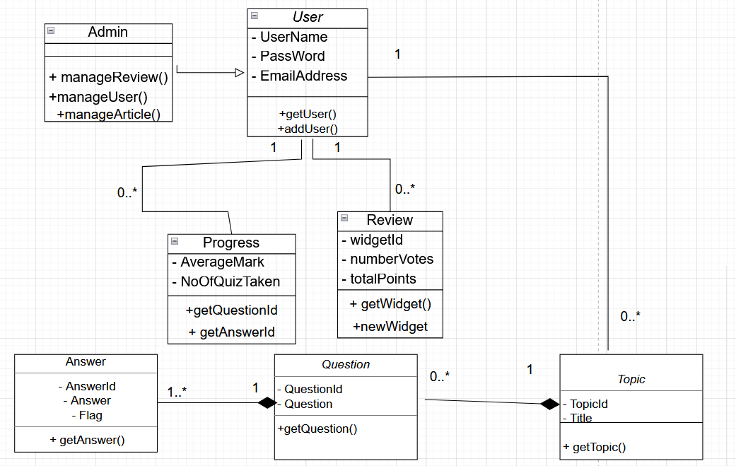

This is a class diagram that has the combined login systems with each topic, the admins association with the user, and the relationships between the questions and answers classes showing that for every question there will be 1 to many answers in the field, likewise with the review and progress classes as its implying that every user will have 0 to many reviews and likewise with the progress.

# 3. Preliminary Design and Prototype

Link to video demonstrating a prototype that should minimally show a sample user interface and discuss your engagement with creating the design and intended functionality.

In this video, also discuss your design documents as well as data preparation and planning.

https://drive.google.com/file/d/1Uhqlf9JhIMygvteti-FXAzait0Ql_VkB/view?usp=sharing

**4. References**

Include a list of cited in your text items (books, papers, websites, etc.). Use Harvard style for the purpose, or any other preferred standard referencing style.

1. Ageuk.org.uk. 2016. [online] Available at: <https://www.ageuk.org.uk/globalassets/age-uk/documents/reports-and-publications/reports-and-briefings/active-communities/rb_july16_older_people_and_internet_use_stats.pdf> [Accessed 21 February 2022].
2. Ons.gov.uk. 2019. *Internet access – households and individuals, Great Britain - Office for National Statistics*. [online] Available at: <https://www.ons.gov.uk/peoplepopulationandcommunity/householdcharacteristics/homeinternetandsocialmediausage/bulletins/internetaccesshouseholdsandindividuals/2019> [Accessed 27 February 2022].
3. Ons.gov.uk. 2019. *Internet users, UK - Office for National Statistics*. [online] Available at: <https://www.ons.gov.uk/businessindustryandtrade/itandinternetindustry/bulletins/internetusers/2019> [Accessed 21 February 2022].
4. Brotherton, C., 2016. *Web Accessibility in the UK – True Facts [infographic]*. [online] A Bright Clear Web. Available at: <https://www.abrightclearweb.com/web-accessibility-in-the-uk/> [Accessed 9 February 2022].

# 5. Bibliography

Include here a list of general reading items (books, papers, websites, etc.). List the items in alphabetical order, using Harvard style to describe them

1. Jama Software. n.d. *Functional requirements examples and templates - Jama Software*. [online] Available at: <https://www.jamasoftware.com/requirements-management-guide/writing-requirements/functional-requirements-examples-and-templates> [Accessed 11 February 2022].
2. (WAI), W., n.d. *Developing Websites for Older People: How Web Content Accessibility Guidelines (WCAG) 2.0 Applies*. [online] Web Accessibility Initiative (WAI). Available at: <https://www.w3.org/WAI/older-users/developing/> [Accessed 20 February 2022].

# Appendix I

Provide additional material, if appropriate, in separate appendices.

Do not include any printed code as an appendix.